Contents
Microsoft Teams 2
Mitel Connect 3
Setting Up Call Routing Options 4
Managing Mitel Remotely 6
Resources 6
Outlook 7
Customization 7
Managing Emails 8
Recovering Deleted Email 9
Creating Meetings 10
Viewing Calendars 12
Disabling Junk Email 13
Automatic Replies (Out of Office) 15
Network Drives 16
Portal Page and Creating IT Tickets 18
CRAM-A-LOT Connections 20
Google 21
Sending Faxes from Outlook 23
Snip and Sketch 24
CSI (Cloud Suite Industrial) 25
Installing and Running CSI 25
Navigating CSI 25
Opening Forms 26
Toolbar 26
Form Components 27
Searching for Records 27
Adding and Changing Records 29

JV Software and I.T. Basics

Microsoft Teams
Microsoft Teams is an instant messaging client that can be used to send messages, alerts, or notifications instantly to JV employees. All employees who have a computer workstation should have access to Microsoft Teams.
Logging into Teams should be setup automatically, but if you ever find yourself logged out for any reason, refer to the image below and match the input fields as shown:
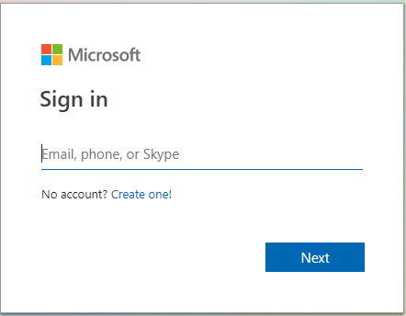
- Username – your JV username you use to login to your computer
- Password – your JV password you use to login to your computer

- Make sure to check “Save Password” and “Auto Login”

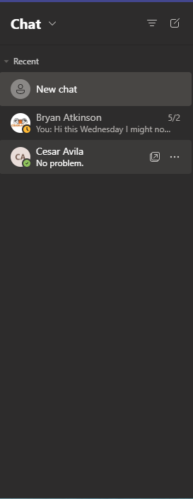

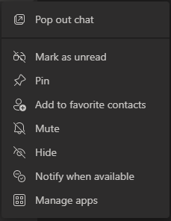
Once you have logged in, you will see a list of all users who are available to chat. Just double click on any name to initiate a conversation. You can have multiple conversations at one time.
Right-clicking on someone’s name will bring up a menu with a couple of useful options. You can start a conversation, view your conversation history, and be alerted when this user is available. This will notify you when that user is back online.
Clicking the  button at the top right corner will bring up a dropdown that allows you to change your status. You can manually change your status to away, on the phone, or do not disturb.
Resources
If you require any further information, you can always access the Teams support website which can be reached by following this link
Get started with Microsoft Teams.

Mitel Connect
Mitel is the phone system and application used at J.V. which can be used to make/take any outgoing/incoming calls to any internal and external phone numbers. Any employee with a computer workstation should have an internal phone number/extension within the ShoreTel system.
The IT Department should help you setup Mitel the very first time so that it always starts up whenever you log in to your computer.
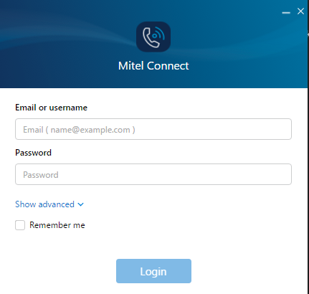
When first opening Mitel you should see this image

- To log in click on Show advanced
- Then you should see
Click on it.
- Next, click on “Remember me” so you will automatically log in next time.

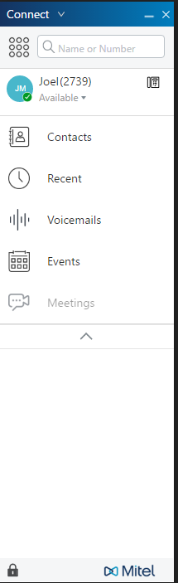

The image below is what the Mitel communicator will look like when you first open it. This is where you can navigate between all the different tabs and view the related information.
Contacts – Use this tab to view or create new contacts that are not already within the ShoreTel directory
Recent Keeps track of all your past phone calls including the date, time, length, and who it was to/from.
Voicemail – This tab stores all your voicemails and play them back, save them, or delete them.

The button will allow you to change your main phone, which is useful if you switch between a hard phone and soft phone.
The button allows you to change your availability on the phone. You can change your status to Out of Office, In a Meeting, or Extended Absence.
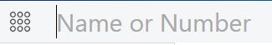
To make a call, type a contact name, or phone number into the space shown below.
Once you have a call going, it will be shown in the communicator as shown below. There are a few quick button options next to the call that allow manipulating the call in a couple of ways.
 – Put the caller on hold.
 – Transfer the call to anther number/extension.
– Create a Conference and add another number to the call.
 – Hang up on the current call.

Setting Up Call Routing Options
Call Routing Options allow you to setup how calls are handled depending on different situations you set that could including being out of office, on vacation, or standard in office days.
To setup call routing options, click on the arrow in the top left of the communicator and go to “Options” you should see an options menu like the one shown below. After selecting settings on the drop down menu select Call Routing.
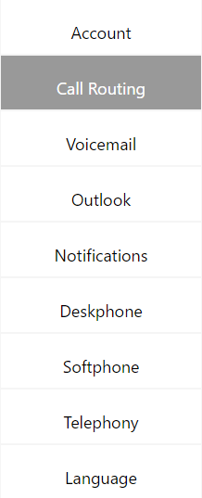
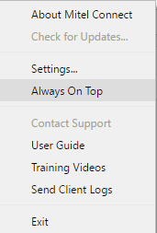

Under the Call Routing Mode, you can see there are 5 options for different call handling mode, including a Custom one that you can setup up for any other reason you may like to have.
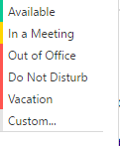

The 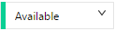call handling mode is the default mode that your phone should be on when you are in the office and available.

To edit a mode, first select the mode you would like to edit from the drop-down menu after “When” at top of the page then make the necessary changes.
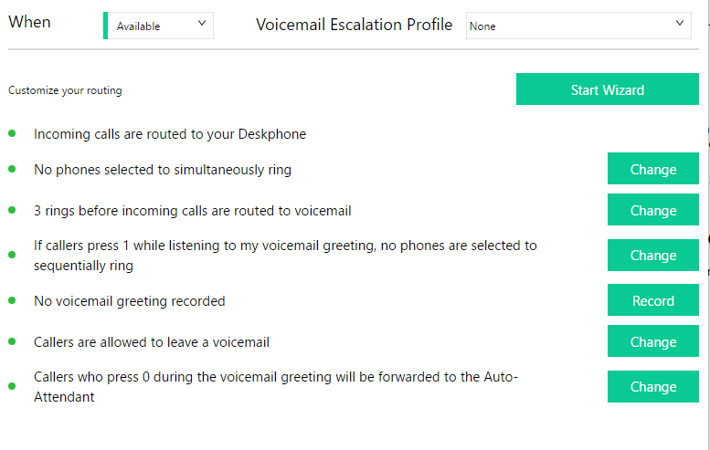

Click on the  button to record the voicemail message for that mode.
Select one of the options for forwarding calls: You can choose to always forward, when there is no answer/busy, or to never forward.
Click on the  button to choose what number to forward calls to. You can enter another extension, 5101 for voicemail, or an outside number like 479-555-1234.
You can also set to transfer the call to another number if the caller presses “0”.

Managing Mitel Remotely
You can change your Mitel options and check your voice mail using a phone from anywhere in the world following these steps:
- Call your office phone number
- When you hear the voicemail greeting, press *.
- At the next prompt, press #.
- When prompted, enter the extension you want to manage.
- Enter the password for the extension you entered, and then press #.

Resources
If you require further help you can always access the Mitel user guide, or the Mitel training videos.
To access either click on the arrow at the top left next to “Connect” then choose either option.
- Once you click on “User Guide” you are taken to
the user guide website. On the website go to
the bottom of the page where you should see
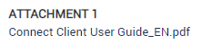
which opens the user
guide as a PDF.

- To access the training videos after clicking Training

videos on the drop-down menu you should be
taken to the website. After getting to the website

select MiCloudConnect. Click on play video once
more than you should see a playlist of many
different videos.

Outlook
Outlook is a Microsoft email application that can be used to send/receive email, make appointments/meetings, and keep track of tasks and set reminders.
The IT department is responsible for creating your company email address and setting up Outlook for the very first time.
If you restart your computer or change your login password, you will have to re-enter your password when you open Outlook. You should get a pop-up message as shown below. Just enter your password and click ok. Also remember to check the “Remember my credentials” checkbox.
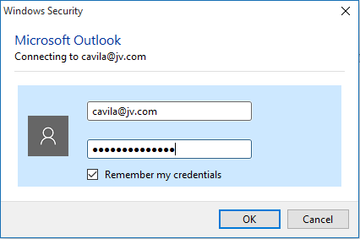

Customization
Once you have Outlook open you should see a window like the one shown below.
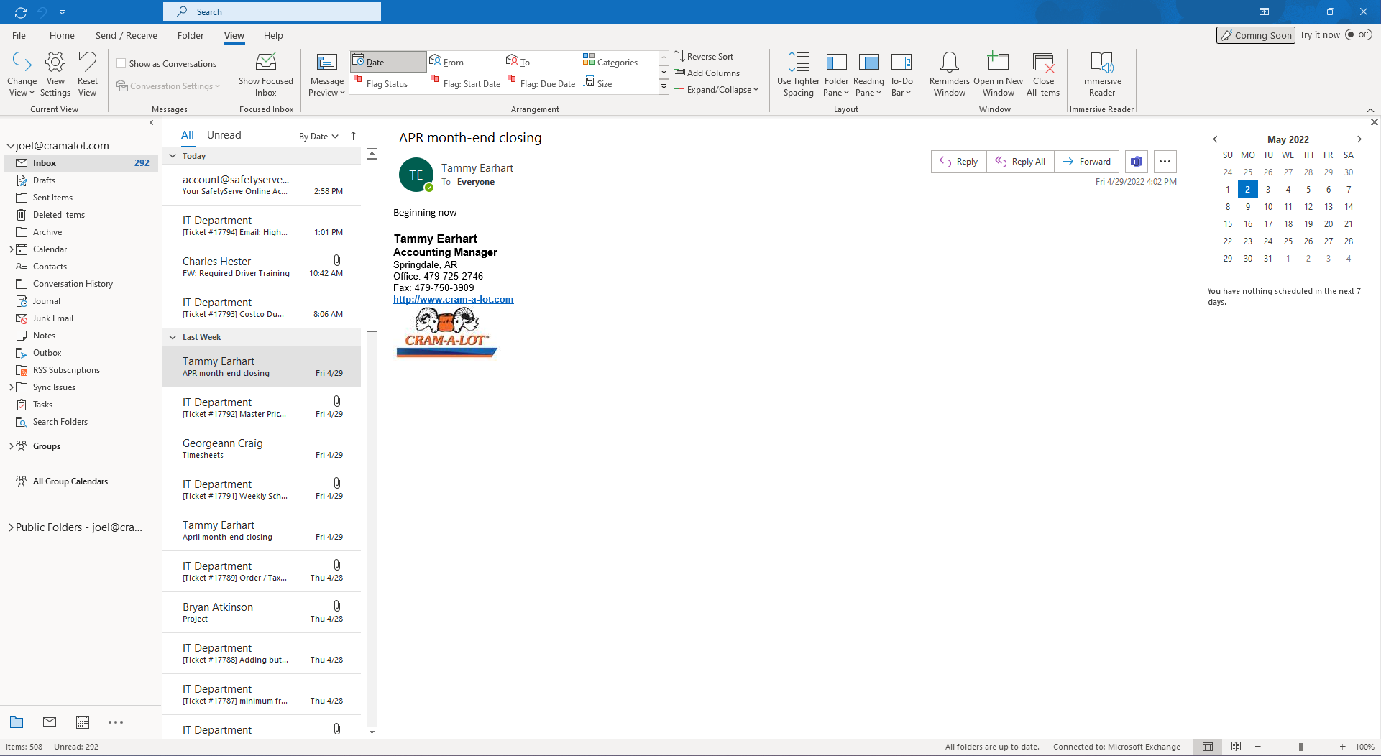
5

4

3

2

1
1

- Taskbar – The taskbar has many different tabs which you can use complete various tasks.
- Navigation Pane – This pane shows all your folders and is useful for navigating between different folders which you can use to separate email.
- Email List – This pane shows all the email you have received or moved to under the specific folder you are under.
- Reading Pane – This pane will show any email you have selected from the email list without having to open the email into a different window.
- To-Do Bar – This pane shows you any upcoming meetings and appointments you have, and any tasks that you may have created for yourself.
These pages are customizable to your liking, and you may choose to include/exclude most of them to fit your needs. Just click on the tab in the taskbar and you should see the menu shown below.
In the Layout Section you can see buttons for the different panes, and you can choose whether to display them or not.

Managing Emails
Managing your emails within Outlook with folders and rules can be helpful if you receive an influx of emails from various people with varying topics.
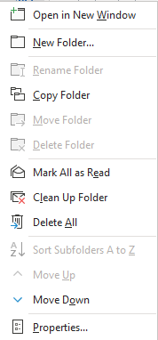
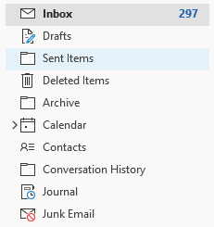
To create a new folder, just go your navigation pane, right-click on the folder you would like to create the new folder under and select the “New Folder” option.
With folders, you can separate emails by subject, sender, recipients, or any other ways to help you organize your email.

Now that you have created folders, you can take advantage of rules. Rules allow you to automatically move, delete, or flag emails based on criteria that you set.
To quickly create a new Rule, first make sure you have selected an email from your Email List with the criteria that you would like to create a rule with.
Now Under the tab you should see a “Rules” button. Click the button and then select the “Create Rule” option.
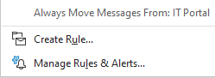

You should see a pop-up window like the one shown below. This will allow you to select some options to setup a basic rule.
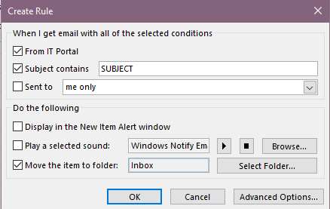
From – Check this if you want the rule to apply all emails from this email address only.
Subject – Check this if your specific criteria for what the Subject should contain
Sent to – Check this if you want the criteria to include who the email was sent to.
Move the item to folder - Check this to specify which folder you would like the emails to be moved to.
Select and the rule will be created for you, and it will allow you to run the rule in the current folder you are in.
If you are looking for more functionality and criteria for rules, selecting the button will give you more options for creating different rules.

Recovering Deleted Email
If you need to recover an email that you deleted in Outlook, there is a way to recover them from within Outlook. You can recover emails that you have deleted up to a 2-week time frame in most cases.
To recover deleted email, first go to your Navigation Pane, and make sure you have selected your folder.

Now go to your tab and look for the “Recover Deleted Items” button as shown below.
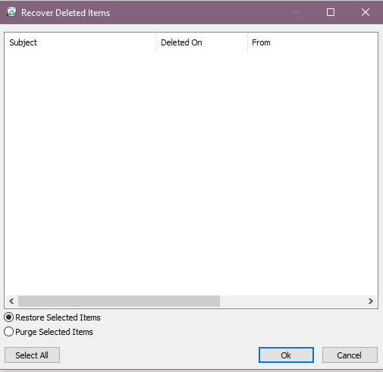
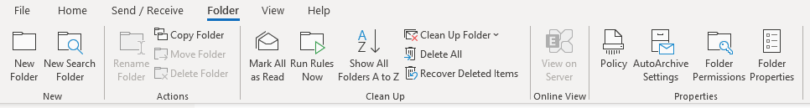

A window like the one shown to the right should pop up.
Just select the emails you want to recover (if you hold down the CTRL button on your keyboard, you can select multiple emails) and hit the button.
These emails should now show back up in your Inbox folder.

Creating Meetings
J.V. uses Outlook Calendars to keep track to employee vacation and off-days, as well as create meeting requests. It should be your go to location to check and see if an employee is out of the office that day.
To create a new meeting just go to the tab, look for the “New Items’ button, and select “Meeting” from the dropdown.
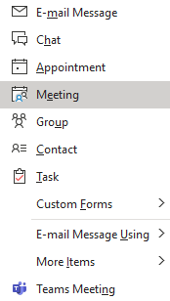
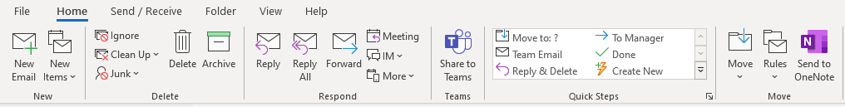
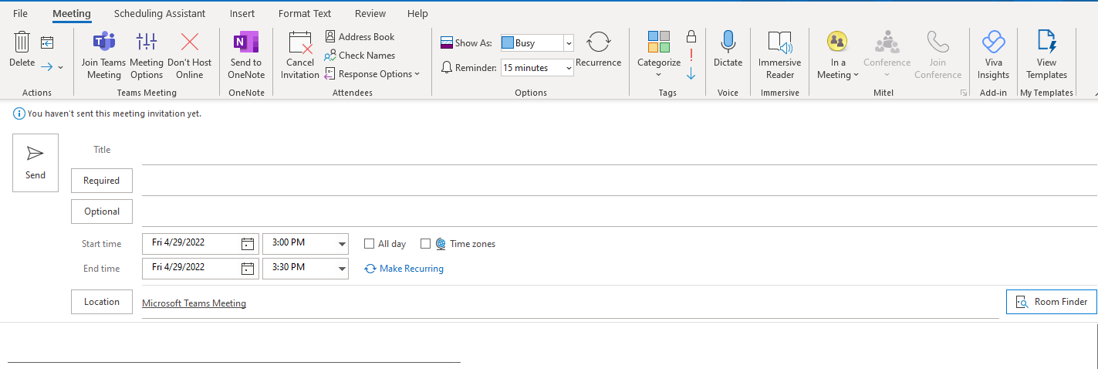

To: Enter in all meeting attendees. (Or you can leave blank if this is just an appointment)
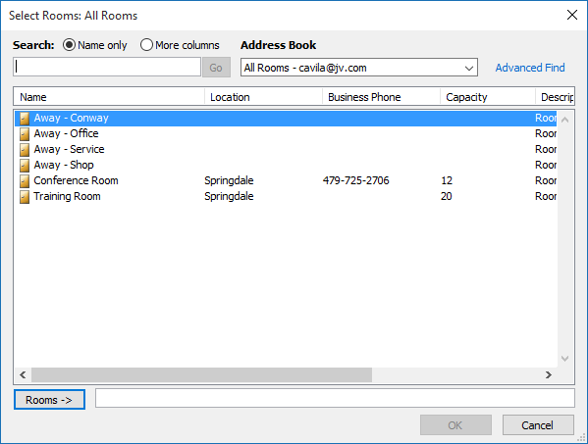
Subject: The subject of the meeting. Include location if it is relevant
Rooms: Instead of entering a location, select the button to assign the meeting to a calendar. A pop-up like the one to the right should show up. Just click on the room you would like this meeting to go to and click OK.
Start/End Time: Enter the date and time of when this meeting will occur.
These are other optional fields which you can use:
Scheduling Assistant: shows a graphical view of an attendees’ presence
Show As: Sets the attendees’ presence to Free, Tentative, Busy, or Out of Office.
Reminder: Alerts attendees before a meeting is to begin.
Recurrence: Use if you want this meeting to occur at regular intervals
Private: Use if you want to hide the meeting details on the “Room” calendar.

Viewing Calendars
To view calendars, go to your Navigation Pane and select the view at the bottom.
Now under your tab, you should see an “Add Calendar” button. Click it and select “From Room List”.
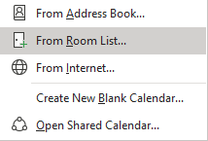
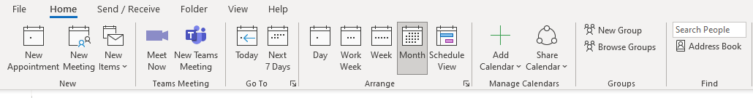

You should see a pop-up with all the Calendars available to view. Just double-click on the one you would like to see and hit OK.
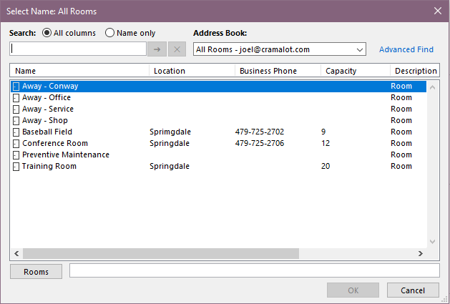
You will only have to do this once for each calendar you would like to view. Any opened calendars will remain open next time you open Outlook, and you should be able to see them listed in your Navigation Pane.

Disabling Junk Email
Outlook has its own junk mail system that checks for junk emails and places them in a junk email folder. However, this can at times cause good emails to end up categorized as junk mail. J.V. already has a spam filter in place to protect you from junk mail, so we recommend you disable Outlook’s system.
First, make sure you are in the section under the Navigation Pane.
Click on the tab, and look for the “Junk” button, then select “Junk Email Options”.
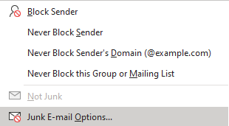
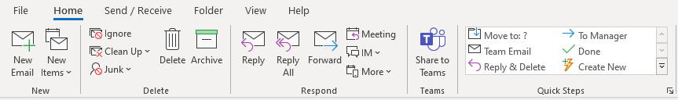

Now in the options window, select the radio button for “No Automatic Filtering” and click Ok. 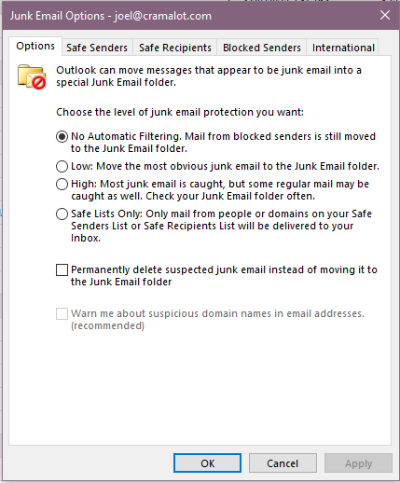

Automatic Replies (Out of Office)
- In Outlook, select the “File” menu.
- Select “Info” on the left side.
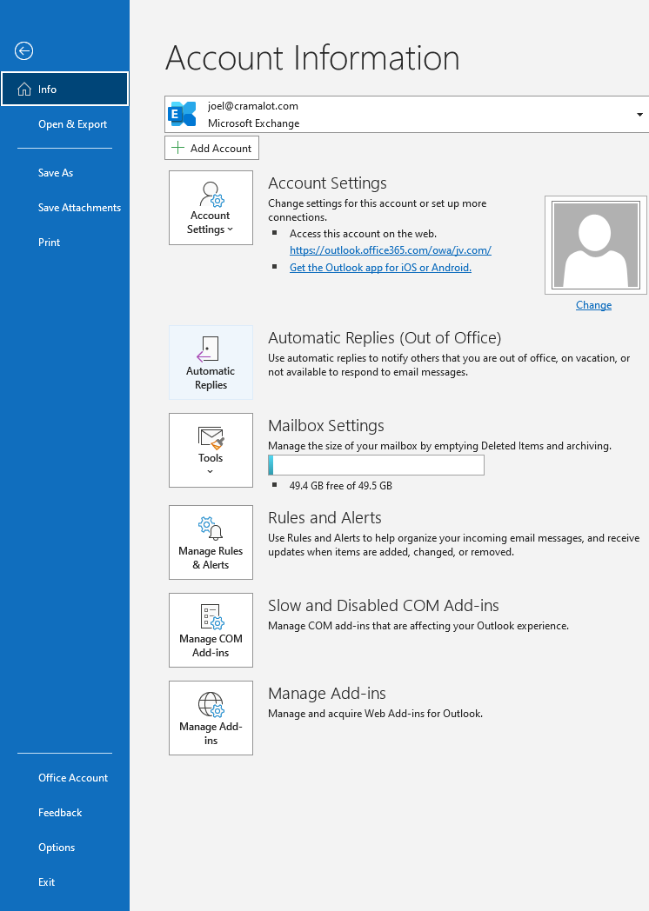
- Select “Automatic Replies (Out of Office) “. If this option is grayed out, you may not be connected to a server that can use this feature.

- Select the “Send automatic replies” option. You can also check “Only send during this time range:” and select a time frame to send the replies.
- Select the “Inside My Organization” tab and type the reply to you would like sent to your co-workers who are on the same mail system.
- Select the “Outside My Organization” tab and type the reply to you would like sent to people outside of your organization.
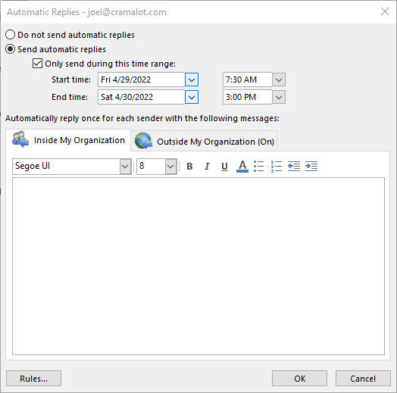

Network Drives
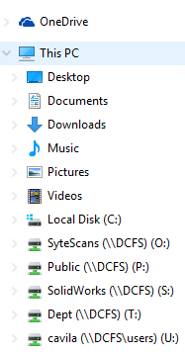
Network Drives are shared folders that can be accessed by multiple J.V employees at any given time. You are connected automatically to these drives based on what department you are in, and the permissions you have been given.
All requests to have access or elevated permission in a specific drive should be directed towards the IT department.
You should be able to see all drives that you have access to by opening a Windows File Explorer and expanding the “This PC” dropdown on the left-hand sidebar.
Each drive is assigned a specific letter and will show a green connection status when online. (If there is a red X by these drives and you cannot connect, please contact the IT department)
Here is a rundown of each drive:
- SyteScans (O Drive) – This drive is commonly used to store files that pertain to data entered into CSI. This includes purchase orders, service orders, emails, pictures, freight confirmations, invoices, etc. All J.V. employees should have access to this drive.
- Public (P Drive) – This drive is used to store anything that can be shared and accessed by anyone. If you have anything that needs secured and restricted access, this is not the drive to save into. All J.V. employees should have access to this drive.
- SolidWorks (S Drive) – This drive is used to store any files or drawings related to the program SolidWorks. This drive can be access by all J.V. employees with limited permissions, and the Engineering Department with full permissions.
- Dept (T Drive) – This drive is segmented by departments, so depending on which department you are under, you will see different folders when accessing this drive. Use this drive to store files that employees, under that specific department, should only have access to.
- Users (U Drive) – Everyone J.V employee with a computer workstation will have their own specific U Drive. Use this drive to store important files that you would like to backup daily.

Portal Page and Creating IT Tickets
The portal page is the home page set on your internet browser which has many useful company links and allows you to create IT tickets which are sent to the IT Department.
http://site/portal/
When you open up a new instance of Internet Explorer you will see the portal page as shown below.
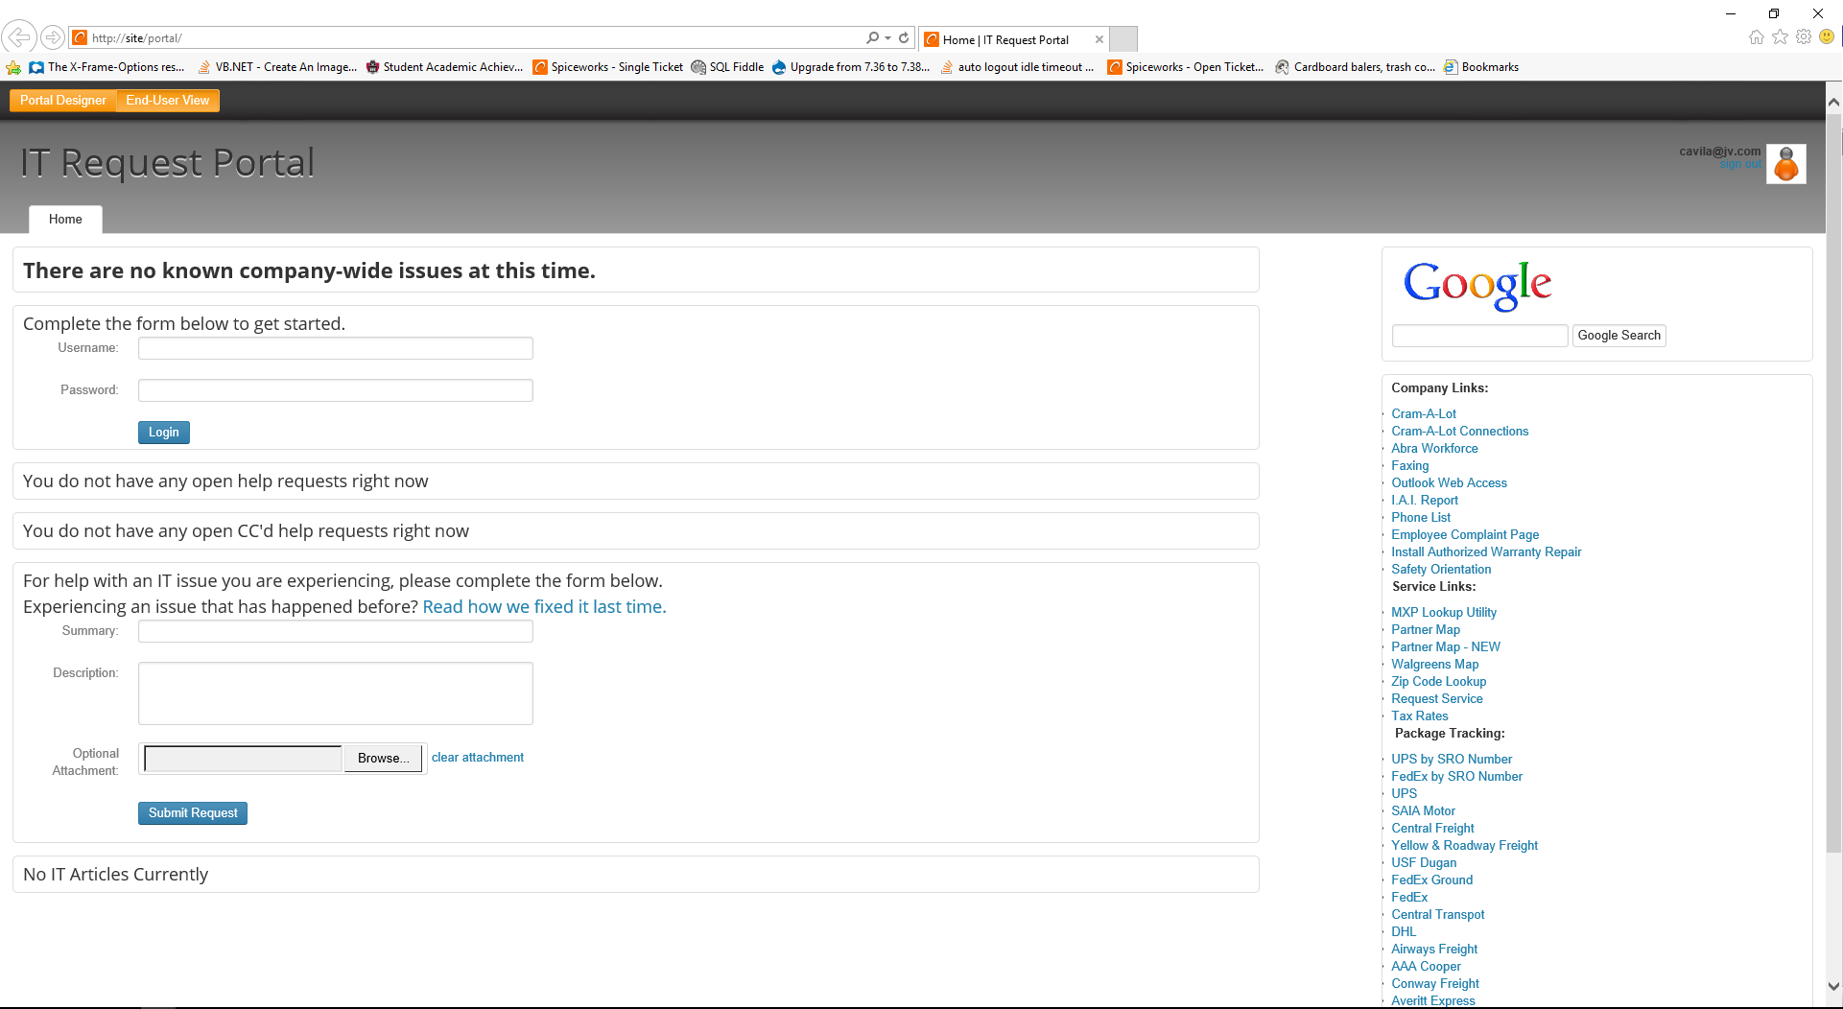
1
3

1
4

6

1
5

1
2

1
1

1
- Company-Wide Issue Banner – This banner is used to notify employees of any company wide issue that may be affecting multiple people. This can include phone issues, email issues, network outages etc. Please make sure your issue is not on this banner before submitting an IT ticket.
- Login Form – Use this form to login into the Portal Page. This makes sure that you ticket you create are linked to your user account and email. (Note: this form will not display if you are already logged in)
- Open Tickets Form – This form will show you all the open ticket requests that you currently have open. Just click on the one you would like to view, and you will be able to respond to the ticket from there.
- Past Tickets Link – This link will let you view all the closed tickets that you have opened in the past. This is helpful if you have a recurring issue and can look up the fix from a previous ticket in the past.
- IT Ticket Form – Use this form to fill out an IT ticket request. Include a Summary that is descriptive and relevant to your issue. In the Description, please make sure to fully explain your issue and include, if applicable, any error messages you receive, what you were doing before the issue occurred, and what applications are being affected.
- Company Links Side-Bar – This sidebar includes many useful company, and service links.

Another way to create tickets is by email. Just create a new email like you would normally, and set the fields to these inputs:
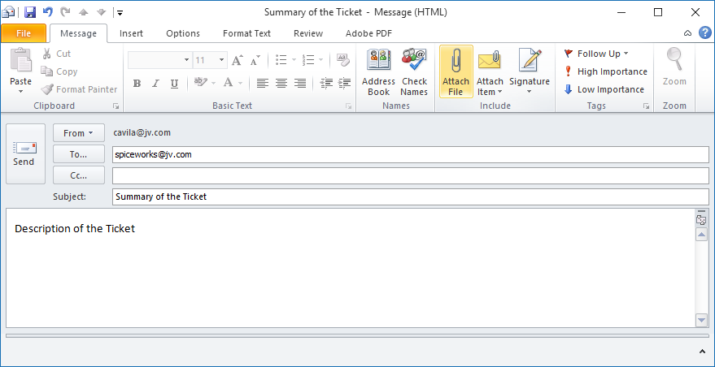
1
- To: spiceworks@jv.com
- Subject: This would be the same as the summary field of the ticket from the Portal Page.
- Body: This would be the same as the description field of the ticket from the Portal Page.
- Attachments (Optional): Attach as many files as necessary, which relate to the ticket issue, by using the “Attach File” button in Outlook.
You will always receive any replies to your tickets as emails. You can respond back to them by email, or through the Open Tickets Form on the Portal Page.

CRAM-A-LOT Connections
CRAM-A-LOT Connections is an internal, employee self-service website that you can use to check your personal information, and time-off.
http://site:81/selfservice/login.php
You can access the site using the link above, or by using the Company Links sidebar on the Portal Page
When you visit the page, you will first see the login screen. Fill out the fields with the required information.
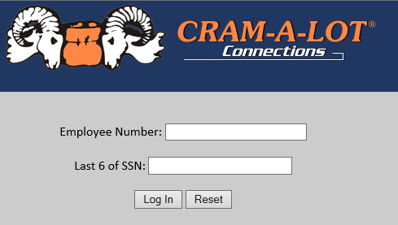
Employee Number: The employee number assigned to you. If you do not know your employee number, you can contact HR for that information.
Last 6 of SSN: This will be the last 6 digits of your Social Security Number. (You can enter this with or without the dashes)

Once you have logged in, you will see a menu as shown to the left. You can use this menu to navigate throughout all the available pages.
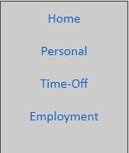
Personal – This includes personal information about you such as your name, age, birth date, etc. This also includes your current address. If any of this information is incorrect or has changed, you can contact HR to get it updated.
Time-Off – This page includes information about the amount of time-off you have accumulated, and how much you have taken.
Employment - This page will show you your current employment information annual pay, salary, pay frequency, etc.
If you are a supervisor, you will notice an additional tab in the menu. You can use this page to view information about all the employees you supervise. This includes their personal information, and time-off.
Note: For added security, this site will automatically log you off after 5 minutes of inactivity.

Google
Google can be a very helpful tool to use when searching for common technical problems. Trying a quick Google search before submitting a ticket can sometimes lead to faster solutions. Generally, how-to’s, minor technical issues, or missing buttons/bars on common programs can be quickly resolved by using a quick online search.
Here are a few examples of common tickets that could be solved by searching online:
How do I turn a word document into a PDF?
This is an easy how-to that can be searched up online. If you search this exact same phrase “How do I turn a word document into a PDF” in Google, the first result will give you these step-by-step instructions on how that is done.
- Open a file in an Office application.
- Click Create PDF in the Acrobat ribbon.
- Select Protect PDF in the resulting dialog box.
- In the next dialog box, set up a password and file permissions as desired to restrict people from copying or editing the file.
- Click OK, name the PDF file, and save it in a desired location.
Pages on Internet Explorer look zoomed out.
This is an easily fixable problem that can be searched for online. Remember to be specific about what the issue is and what program it is affecting. In this case you would want to include the browser that is having the issue, so a good search phrase would be “How do I change the zoom level on Internet Explorer”. Most of the first few results will get you the same answers, and in this case, the first result gave us these solutions:
- In Internet Explorer, on the View menu, point to Zoom, and then select a different level.
- If you have a mouse with a wheel, hold down the CTRL key, and then scroll the wheel to zoom in or out.
- By using the keyboard, you can increase or decrease the zoom value in 10% increments. To zoom in, press CTRL+PLUS SIGN (+). To zoom out, press CTRL+MINUS SIGN (-). To restore the zoom to 100%, press CTRL+0
My printed documents are going to the wrong printer.
This is a setting that can be quickly changed on your computer. Searching the phrase “How to change your default printer” should quickly give you a solution. I found this on the first result:
- To select a default printer. Open Devices and Printers by clicking the Start button, and then, on the Start menu, clicking Devices and Printers. Right-click the printer you want to use, and then click Set as default printer. (You'll see a check mark on the printer's icon signifying that it's now your default printer.)
  - Note: The steps above are applicable to Windows 7. If you know what operating system you are using, it is helpful to include that in the search phrase.

Sending Faxes from Outlook

- Create a new email message

- In the to: field, enter: recipient/company/phone fax@jv.faxlogic.com

(Recipient, company, phone and fax will appear on the cover sheet)

Example: John Doe/CVS/777-888-9999 222-333-4444@jv.faxlogic.com

Note the space between the recipient/company/phone and the fax number.

You can also omit any or all the recipient/company/phone part. For example: Bob Jones/Walmart 222-333-4444@jv.faxlogic.com
Bob Jones 222-333-4444@jv.faxlogic.com

222-333-4444@jv.faxlogic.com

2223334444@jv.faxlogic.com

- In the Subject: field, enter subject (Note: subject will appear on the cover sheet)

Example: This is the subject text that will appear

- [Optional] Type a message in the email body
(Note: This is the “Memo” area on the cover sheet)

- Attach one or more documents. Supported formats include Word, Excel, PowerPoint, Publisher, PDF, TIFF, BMP, GIF, JPG, and PNG.

- Click Send

- Image below of what email should look like when completed. You can omit most of this as shown above.

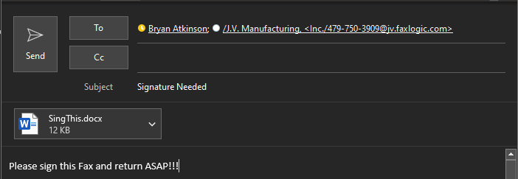

Snip and Sketch
Snip and Sketch is a pre-installed program on Microsoft Windows operating systems which can be used to take screenshots of any open windows you may have or an entire screen. Snip and Sketch can be used when you need to show an error message of specific issue that is happing on your monitors only.
- To find the Snip and Sketch Tool, just go to your Start button and start typing in “Snip and Sketch”. (You should see it pop up as one of the first options.)
- An easier way to access Snip & Sketch is by simply pressing + Shift + S which will give you the option to take a screen shot of what is currently on your screen.

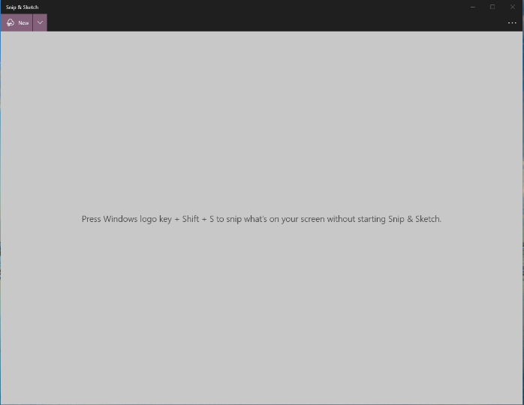
- Once you open the Snip and Sketch Tool you should see the image below, just click on the “New” button to start. You should notice a white overlay appear across your screens. This means the tool is ready and you can start dragging the tool over the specific part of the screen you want to capture.

- Once you have taken a screenshot, you should see a couple new options in the toolbar as shown below. You can now use the pen or highlight tool to make markings of the image. You can also choose to send the image by email. 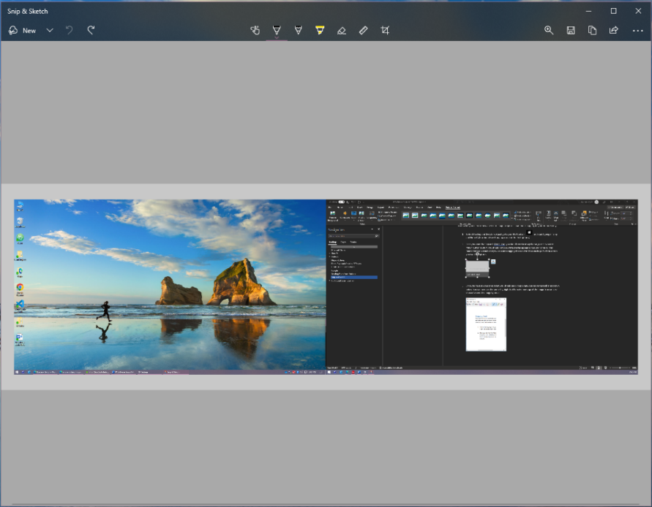

CSI (Cloud Suite Industrial)

Installing and Running CSI
To install/launch CSI, click the appropriate link below or use an existing icon on your computer (usually located in All Programs -> Infor):
- Live - \\CSI\SyteLine\SLClientDeploy\SyteLine.application
- Test - \\CSIT\SyteLine\SLClientDeploy\SyteLine.application
You will be presented with the following login prompt:
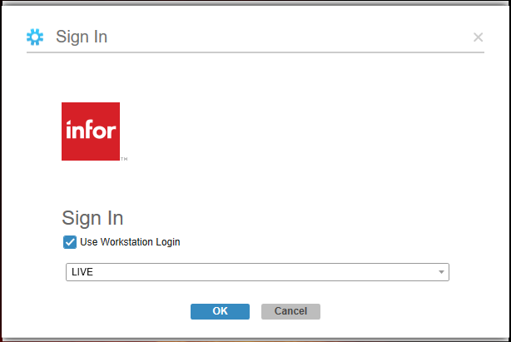
Check the “Use Workstation Logon” box instead of entering a username and password. Make sure to select a configuration (there should only be one option).

Navigating CSI
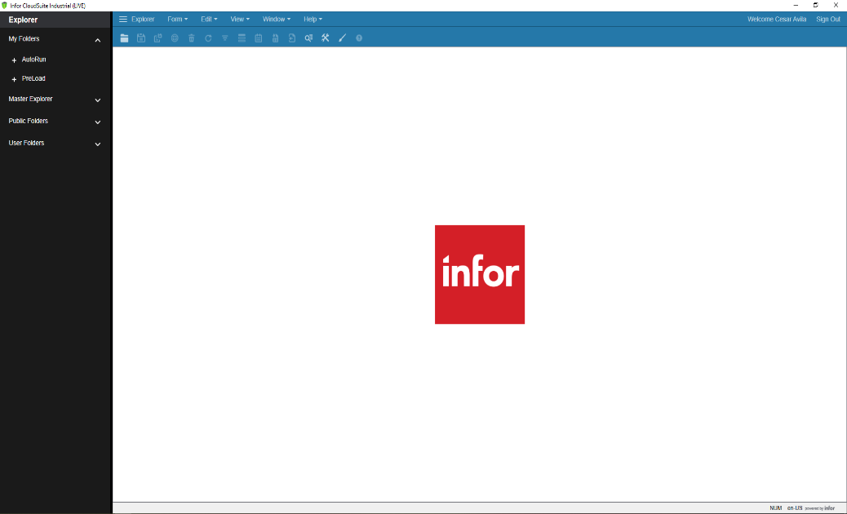
Once logged in, you will be presented with the following screen:
1
- Menu Bar – Used to open forms, change views, and perform various functions within forms
2
3
1
- Toolbar – Used primarily to navigate and save within forms
- Explorer – Displays My Folders (shortcuts to frequently used forms) and the Master Explorer (lists all forms in CSI)

If you do not see any of the items numbered above, you can show them by clicking View in the menu bar then selecting the item that is missing.

Opening Forms
Forms provide a way to see and interact with data that is saved in a database. You can open a CSI form a few different ways:
- Click Form in the menu bar then select Open (or select from the list of recent forms listed)
- Double click a form listed in your My Folders* section
- Navigate through the Master Explorer to find the desired form
* To add a form to your My Folders list, find the desired form within the Master Explorer. Right click on the form name and choose Copy. Then return to the My Folders window, right click, and select Paste

Toolbar
After a form is opened, many of the toolbar functions become available. There are other components on the toolbar that are not pictured, but they are rarely used. If any buttons are grayed out, then their functionality is disabled. Hovering your mouse over a button will cause it to display its function. Here are the uses of the primary buttons:
 - Opens forms
 - Saves the changes made on the form
 - Saves the current changes and closes the form (if the save button is grayed out then using this button WILL NOT save changes)
 - Creates a new record
- Deletes the selected record
 - Refreshes all records currently displayed on the form
- Begins or closes “Filter in Place” mode (also known as search mode)
- Gets more rows in the currently displayed form. By default, it will grab 200 more rows until all the relevant data has been retrieved.
- Access notes saved to the current record (yellow means the record contains notes)
- Sends all records on the form to Excel
- Shows the Help information for the current form

Form Components
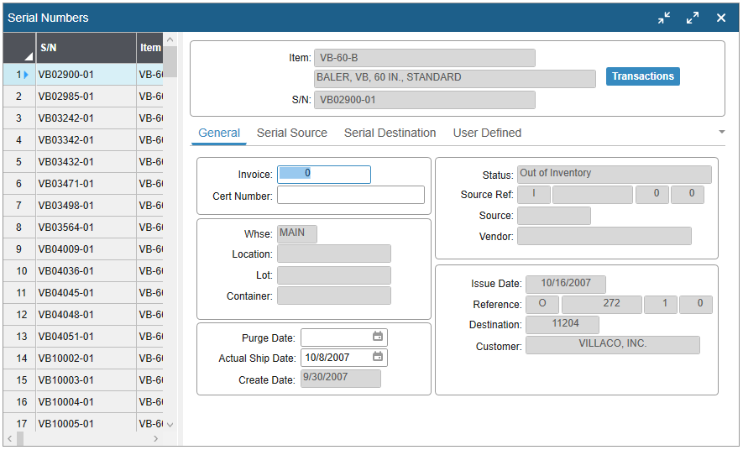

1

2
Most, but not all, CSI forms are composed of two primary sections:
- Grid – The area to the left that lists records in an Excel style format
- Form – The right-side area that shows all fields for a record in a custom layout
In between the Grid and Form is a Slider Bar which can be used to increase or decrease the amount of each section that is displayed. You may also use the hotkey function CTRL+2 to switch to “all grid” mode.

Searching for Records
When opening a form, it can either open in “refresh” mode which displays all records immediately after opening the form or “filter in place” mode which allows for searching for groups of records. You can toggle modes by clicking the magnifying glass icon in the toolbar.
It is important to note that there is a “search history” that is remembered each time you toggle “filter in place” mode. That means that if you do a search, toggle using the magnifying glass, then begin another search you will notice that the first search criteria are still shown. This “search history” is remembered until the form is closed.
To begin searching for records, you need to first activate “filter in place” mode using the magnifying glass icon (if it is not already active). A form will display “Filter in Place” next to the form name if “filter in place” is currently active. With “filter in place” mode active, you search for specific records or groups of records by adding criteria to fields on the form.
For example, if I wanted to see the details about the VB-60-B then I could:
- Open the Items form
- Activate “filter in place” mode (if it is not already)
- Enter VB-60-B into the Item field
- Turn off “filter in place” mode
This should return information specific to the VB-60-B. Similarly, if you wanted to return information for all purchase items then you could:
- Open the Items form
- Activate “filter in place” mode (if it is not already)
- Select Purchased from the Source field
- Turn off “filter in place” mode
This will list information about all purchased parts (it will probably just return the top 200 due to your Record Cap, but we will get to that later). You can also use arithmetic functions to search on items. For example, if I wanted to see all items that we have over 1000 in stock then I could:
- Open the Items form
- Activate “filter in place” mode (if it is not already)
- Enter >1000 into the Quantity on Hand field
- Turn off “filter in place” mode
Searching is not limited to a single field. If I wanted to see all items that we have over 1000 in stock AND are stocked in inches, then I could:
- Open the Items form
- Activate “filter in place” mode (if it is not already)
- Enter >1000 into the Quantity on Hand field
- Select IN from the Unit of Measure (U/M) field
- Turn off “filter in place” mode
You can also use wildcards to search where complete information is unknown or not important. The CSI wildcard character is the asterisk (*). Below is an example to show how to search for all items that are in the VB-60 family:
- Open the Items form
- Activate “filter in place” mode (if it is not already)
- Enter VB-60* into the Item field
- Turn off “filter in place” mode
You should see VB-60-B, VB-60-H, VB-60-X, and many others listed in the grid of the items form. This is because our criteria stated to show us all items that start with VB-60 then have anything else after that.
Wildcards are very powerful for searching but can also get a bit confusing. Here are some examples of different wildcard uses in the item field as well as the results they will return:
- VB-*-X Shows all “heavy duty” balers regardless of the size
- *-LP Shows all “low profile” equipment
- *-20-* Shows all 20-yard equipment
- *-20-*LP Shows all 20-yard “low profile” equipment

Adding and Changing Records
Within a form, you can click the new button to begin creating a new record. Note that the new line on the grid should have a () next to it as pictured below.
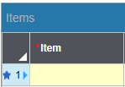
This () indicates that this is a new record that will be added to the database whenever the save button is clicked. There are four different record statuses indicated by a icon:
- () – new; record will be added into the database after a save
- () – deleted; record will be removed from the database after a save
- () – modified; changes will be made to the record after a save
- () – error; record will not be saved because there is a problem
You will notice that some fields are different in color. Each color has a specific meaning:
- White – optional; it is not required to enter data into this field in order to save
- Yellow – required; data must be entered into this field before the record can be saved
- Gray – disabled; data entry in this field is not possible
- Green – sequencing; if no data is entered into this field, then CSI will pick the next higher number in sequence
You may also notice that some fields may contain data already immediately after you click to enter a new record. This is because the field has been set with “default data” that shows up automatically.
Data can be entered into either the form fields or the grid fields. You can use the Tab key to navigate from field to field or use a mouse to click on desired fields.
The new record can be saved after all required fields have valid data entered.

